Mary Montgomery School
Grade 1P- Mrs. Pidborchynski & Grade 1W- Mrs. Wood-O’Grady
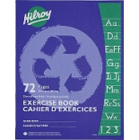
2021-2022
- 2 coloured pocket folders
- 5 Hilroy dotted interlined exercise book (full page interlined)
- 1 duo tang
- 1 hard plastic pencil case
- 1 package of pencil crayons (24)
- 1 package of crayons (24)
- 1 handheld pencil sharpener with canister
- 1 package Crayola markers
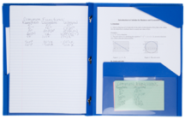
- 5 Expo brand thin dry erase markers
- 1- 5 Star brand plastic duotang with pockets
- 1 binder (1 inch), please no zippered binders
- 1 set of labelled headphones in a ziploc bag
- 1 pair runners
- 1 box of Kleenex
Please mark all belongings with the child’s name or initials.
Dear Mary Montgomery School Families:
The school is purchasing classroom sets of scissors and rulers from our school budget. We have also decided to purchase in bulk- pencils, erasers, glue (sticks & white glue) and bristol board for art folders. We are asking for $10.00 per student to cover the cost of these items.
We are continuing to ask for $10.00 per student as student fees. One dollar of this fee is provided to our Parent Advisory Council. The other $9.00 will be used to purchase specific art supplies for special occasions such as… making Christmas presents and Mother’s/Father’s Day gifts.
We are asking each family to submit $20.00 by September 30th, 2021. You are more than welcome to post date cheques to September 30th.

