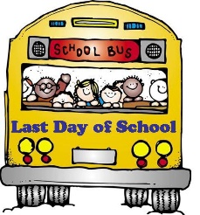
Mary Montgomery School
2020-2021 Supply List Grade 2M
Mr. K. McLeod
- 2 small pencil sharpeners
- 6-40-80 page Hilroy scribblers
- 4 Duotangs with metal clips
- 5 Folders with inside pockets
- 1-24 pack of sharpened pencil crayons
- 1-24 pack of water soluble markers
- 2 pencil cases
- 1 pair of non-marking indoor shoes (Please do not send shoes with laces if your child cannot tie shoes yet)
- 1 set of headphones (can use the same ones as last year if they still work)
- 1 box of Kleenex

Dear Mary Montgomery School Families,
The school will once again buy basic items such as scissors, rulers, extra pencils, erasers, extra notebooks, glue and more. We are asking for $10.00 per student to help cover the cost of these items. We are also asking for $10.00 per student for student fees. One dollar of this fee is provided to our Parent Advisory Council. The remaining money will be used to purchase specific art supplies to be used throughout the year.

Mr. McLeod

