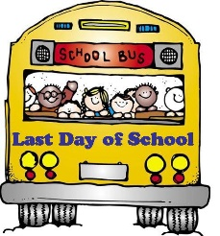
Mary Montgomery School
2021-2022 Supply List Grade 2P
Mrs. Pearn
- 2 small pencil sharpeners
- 8- 32 page Hilroy notebooks (no coils please)
- 6 Duotangs with metal clips
- 1-24 pack of sharpened pencil crayons
- 1 Large pack of water soluble markers (I highly recommend Mr. Sketch Markers, they cost more but last the entire year)
- 2 pencil cases (1 for markers and pencil crayons, 1 for everything else)
- 1 pair of non-marking indoor shoes (Please do not send shoes with laces if your child cannot tie shoes yet, labelled please)
- 1 set of headphones NO earbuds please (can use the same ones as last year if they still work) **please send them in a LABELLED Ziploc bag
- 1 box of Kleenex
- 1 box of Large sized Ziploc bags
- 2 packages of sharpened pencils with names on them
- 2 package of erasers
- Please note** we use an agenda for family/teacher communication in our classroom, they are ordered by the school. The agenda fee is added onto the total school fees at the bottom of this list
Dear Mary Montgomery School Families,
The school will once again buy basic items such as scissors, rulers, extra pencils, erasers, extra notebooks, glue and more. We are asking for $10.00 per student to help cover the cost of these items. We are also asking for $10.00 per student for student fees. One dollar of this fee is provided to our Parent Advisory Council. The remaining money will be used to purchase specific art supplies to be used throughout the year. Our Agenda fee is $10.00.
Please send in the $30.00 student fee, by cash, cheque or etransfer, no later than Sept. 30th. Cheques can be posted dated for Sept. 30th if necessary.
****PLEASE LABEL ALL SCHOOL SUPPLIES WITH YOUR CHILD’S NAME*****

