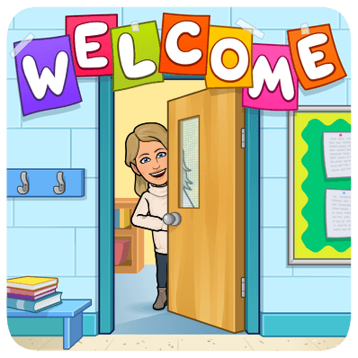
Mary Montgomery Mrs. Hole’s Kinder Supply List 2021/2022
❑ $20 supply/student fee. Cash, E-Transfer, or cheques payable to Mary Montgomery School. $10 of this money will go to buy your child’s school supplies. In the Kindergarten classroom, shared supplies works best for classroom management and clean-up. It also helps save you money as not every child needs their own set of supplies and it is much cheaper for me to buy large packages that we all share. $10 of this money is the school fee charged to all Mary Montgomery students. $1 of that $10 goes to Parent Advisory Council and the rest goes to the office to cover items such as shared arts supplies, gifts for holidays such as Christmas, Mother’s Day, Father’s Day, etc.
❑ All forms in the kinder package that was sent with this letter.
❑ Backpack and lunch kit
❑ 1 pair of Velcro or slip-on indoor shoes (non-marking soles please)
NO TIE SHOES PLEASE! Try to purchase shoes that your child can put on
independently as there is not enough time to help each child with shoes
in a large class. These shoes will be worn for gym class so they must be suitable for running.

❑ Extra set of clothes (pants, shirt, socks, underwear) in a Ziploc bag labelled with name. This will stay in their locker all year in case of accidents or spills. Please do not buy a new outfit for this- an old, stained outfit is just fine!
❑ Paint shirt- an old shirt from Mom or Dad works great!
❑ Proper outdoor footwear and clothing each day. Our program is outdoors on a regular basis as I believe that outdoor learning is very important for young children. Please check the weather for the day and be sure to send your child to school dressed for learning outside each day.

If you have any questions please feel free to contact Mrs. Hole at jhole@flbsd.mb.ca.

